**Database Lab** CSE 3104

**Session 04**

Munshi Rejwan Ala Muid Page 1

**4 ERD**

**Why ERDs?**

Entity Relationship Diagrams are a major data modeling tool and will help organize the data in your project into entities and define the relationships between the entities. This process has proved to enable the analyst to produce a good database structure so that the data can be stored and retrieved in a most efficient manner. By using a graphical format it may help communication about the design between the designer and the user and the designer and the people who will implement it.

**4.1 Components of ERD**

An ERD typically consists of four different graphical components:

• **Entity. (Nouns)**

A data entity is anything real or abstract about which we want to store data. Entity types fall into five classes: roles, events, locations, tangible things or concepts.E.g. employee, payment, campus, book. Specific examples of an entity are called **instances**. E.g. the employee Karim Rahman, Hashim Khan's payment, etc.

• **Relationship. (Verb)**

A data relationship is a natural association that exists between one or more entities. E.g. Abdul ***borrows*** Loan-1.

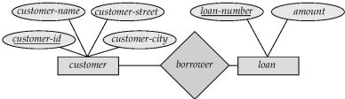

Munshi Rejwan Ala Muid Page 2

• **Cardinality. (Adverbs)**

Defines the numerical attributes of the relationship between two entities or entity sets.

Different types of cardinal relationships are:

∙ **One-to-One Relationships:** A customer is associated with at most one loan via the relationship *borrower*. A loan is associated with at most one customer via *borrower*

∙ **One-to-Many Relationships:** In the one-to-many relationship a loan is associated with at most one customer via *borrower*, a customer is associated with several (including 0) loans via *borrower*

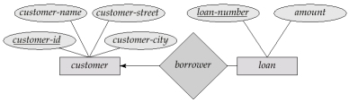

∙ **May to One Relationships:** In a many-to-one relationship a loan is associated with several (including 0) customers via *borrower*, a customer is associated with at most one loan via *borrower*

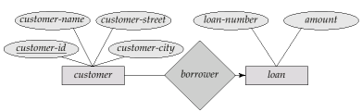Munshi Rejwan Ala Muid Page 3

∙ **Many-to-Many Relationships:** A customer is associated with several (possibly 0) loans via borrower. A loan is associated with several (possibly 0) customers via borrower

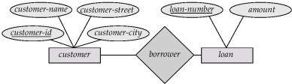• **Attribute. (Adjective , But they are often Nouns)** It is a single-valued property of either an entity-type or a relationship-type. ⯍ **Simple and composite attributes.**

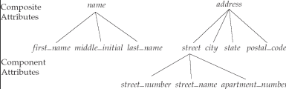

⯍ **Single-valued and multi-valued attributes**

∙ Example: single valued: age, multivalued attribute: *phone_numbers(one may have multiple phone no)*

Munshi Rejwan Ala Muid Page 4

⯍ **Derived attributes**

∙ Can be computed from other attributes

∙ Example: age, given date_of_birth

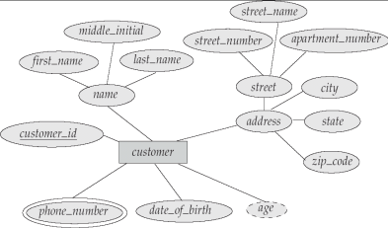

Munshi Rejwan Ala Muid Page 5

**4.1 Notations or Symbols for drawing ERD**

Rectangles represent entity sets.

∙ Diamonds represent relationship sets.

∙ Lines link attributes to entity sets and entity sets to relationship sets.

∙ Ellipses represent attributes

- Double ellipses represent multivalued attributes.

- Dashed ellipses denote derived attributes.

∙ Underline indicates primary key attributes

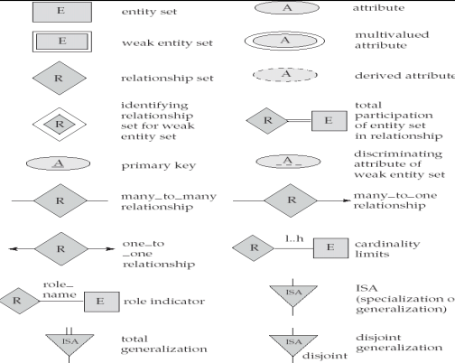Munshi Rejwan Ala Muid Page 6

**4.2 One Methodology for Developing an ERD**

Now in this ERD Diagram Tutorial, we will learn how to create an ER Diagram. Following are the steps to create an ER Diagram:

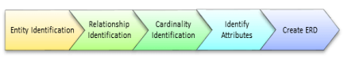Let's study them with an Entity Relationship Diagram Example:

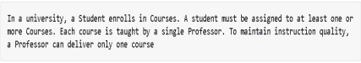**Step 1) Entity Identification**

We have three entities

∙ Student

∙ Course

∙ Professor

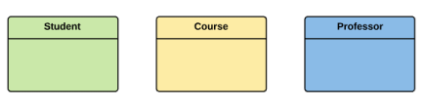Munshi Rejwan Ala Muid Page 7

**Step 2) Relationship Identification**

We have the following two relationships

∙ The student is **assigned** a course

∙ Professor **delivers** a course

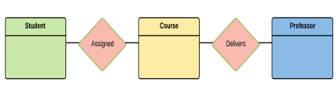

**Step 3) Cardinality Identification**

For them problem statement we know that,

∙ **A** student can be assigned **multiple** courses and **a** course can be assigned to **multiple** students

∙ **A** Professor can deliver only **one** course and **a** single course is taught by only **one** Professor.

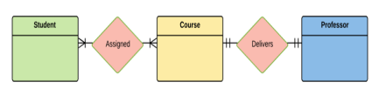**Step 4) Identify Attributes**

You need to study the files, forms, reports, data currently maintained by the organization to identify attributes. You can also conduct interviews with various stakeholders to identify entities. Initially, it's important to identify the attributes without mapping them to a particular entity.

Once, you have a list of Attributes, you need to map them to the identified entities. Ensure an attribute is to be paired with exactly one entity. If you think an

Munshi Rejwan Ala Muid Page 8

attribute should belong to more than one entity, use a modifier to make it unique. Once the mapping is done, identify the primary Keys. If a unique key is not readily available, create one

Entity Primary Key Attribute

Student Student_ID StudentName

Professor Employee_ID ProfessorName Course Course_ID CourseName

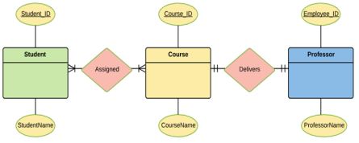For Course Entity, attributes could be Duration, Credits, Assignments, etc. For the sake of ease we have considered just one attribute.

**Step 5) Create the ERD Diagram**

A more modern representation of Entity Relationship Diagram Example

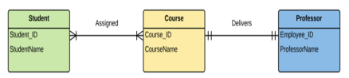Munshi Rejwan Ala Muid Page 9

**E-R Diagram with a Ternary Relationship:**

 Example: *Suppose employees of a bank may have jobs (responsibilities) at multiple branches, with different jobs at different branches. Then there is a ternary relationship set between entity sets employee, job, and branch*

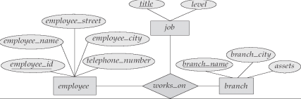Munshi Rejwan Ala Muid Page 10